COMMERCIAL OFFER
FOR Galves taure 2016

Price list, staying in the hotel:
Type of room | Price per night
Triple | 72,00 EUR
Double | 55,00 EUR
Single | 46,00 EUR
More information about hotel:
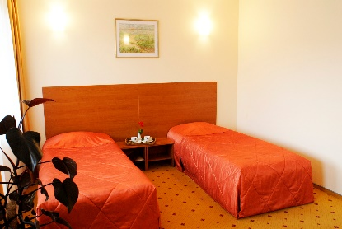
http://www.trasalis.lt/index.php?id=1002

The price includes:
- breakfast (buffet);
- gym (1 hour);
- swimming pool and sauna complex (2 hours)
- salt room
.

Information and room reservation:
Tel. +370 528 51588
Mob. +370 699 52085
E-mail: hotel@trasalis.lt

